An Intelligent Queue Monitoring and Service Optimization Platform

DESIGN THINKING AND INNOVATION
PROJECT REPORT

Submitted by Team:Kryptexa
E.Prathyusha Regd No: 24KD1A0590

G.Meghana Sree Regd No:24KD1A05C8

G.Poojitha Regd No:24KD1A05C0

G.Sowjanya Regd No:24KD1A0593

D.Tejaswi Regd No: 24KD1A0575

S.Anitha Regd No: 24KD1A05Y6

JUNE 2026

DEPARTMENT OF COMPUTER SCIENCE AND ENGINEERING





BONAFIDE CERTIFICATE
Certified that this Design Thinking and Innovation Report, “MediQ.” is the bonafide work of

Team: Kryptexa

E.Prathyusha Regd No: 24KD1A0590 G.Meghana Sree Regd No: 24KD1A05C8 G.Poojitha Regd No: 24KD1A05C0
G.Sowjanya Regd No: 24KD1A0593
D.Tejaswi Regd No: 24KD1A0575
S.Anitha Regd No: 24KD1A05Y6

who carried out the project work under my supervision.

Mrs Suchitra Reyya Dr A Rama Rao
Associate Professor Professor
Dept of CSE Dept of CSE

Submitted for the End Semester
Examination viva-voce held on :

Internal Examiner External Examiner

Table Of Contents

Chapter | Topic | Page
1 | Executive Summary | 1-3
 | 1.1 Overview of the Project / Idea | 1
 | 1.2 Key findings and Outcomes | 1
 | 1.3 Purpose of the Report | 3
2 | Introduction | 4-7
 | 2.1 Scope and objectives | 4
 | 2.2 Relevance of Design Thinking and Innovation | 4
 | 2.3 Background Context | 6
3 | Methodology | 8-10
 | 3.1 Design Thinking framework | 8
 | 3.2 Research methods | 8
 | 3.3. Innovation approach | 9
4 | Empathize | 11-14
 | 4.1 Stakeholder analysis | 11
 | 4.2 User research findings | 12
 | 4.3 Personas | 13
 | 4.4.Empathy maps | 13
 | 4.5 Pain points / Key Points and needs**** | 14
5 | Define | 15-16
 | 5.1 Problem statement | 15
 | 5.2 Point of view (POV) synthesis | 15
 | 5.3 Opportunity Areas | 15
6 | Ideate | 17-20
 | 6.1 Brainstorming Sessions | 17
 | 6.2 Ideation techniques used (like Mind Mapping, Coral Draw, Flowcharts ) | 18
 | 6.3 Idea evaluation criteria ( Ideation Mechanism from Group) | 19
 | 6.4 Shortlisted concepts | 20

7 Prototype 21-22
7.2 Description of Prototype 22
7.3 Tools and Materials used 22
8 | Test 23-24
8.1 User Testing Methodology 23
8.2 Feedback and Observations 24
8.3 Lessons Learned 24
9 | Innovation Strategy 25-27
9.1 Innovation goals 25
9.2 Business model implications 25
9.3 Implementation roadmap 26
10 | Conclusion 28
 |  | References
 | ● | Books, articles, tools, and methodologies referenced  Vision & Mission Course Outcomes, Mapping with POs and PSOs
 |  | Appendices (If any)
 | ● | Interview Transcripts
 | ● | Survey data
 | ● | Detailed Personas
 | ● | Additional Diagrams or Charts

Chapter 1

Executive Summary
  - Overview of the Project
MEDIQ is a web-based healthcare application developed to address inefficiencies in traditional patient queue management processes. In many clinical environments, patients experience prolonged waiting times with limited visibility into queue progression, leading to overcrowding, uncertainty, and suboptimal utilization of healthcare resources.

MEDIQ provides a structured and real-time digital solution that enables patients to search for available doctors, schedule appointments, and monitor their position in the consultation queue dynamically. The system offers continuous updates on queue status, estimated waiting time, and timely alerts when a patient’s turn is approaching. This enhances transparency and allows patients to manage their time more effectively.

For healthcare providers, the system includes a dedicated dashboard that facilitates real-time monitoring and management of patient queues. Doctors can initiate and complete consultations, track patient flow, and access analytical insights such as total patient count and average consultation duration. These features support informed decision-making and improved workflow efficiency.

The system leverages a cloud-based backend with real-time data synchronization to ensure seamless communication between patient and doctor interfaces. Additional functionalities, including notification alerts, voice prompts, and visual progress indicators, contribute to improved usability and accessibility.

Overall, MEDIQ aims to optimize queue management in healthcare settings by reducing patient waiting time, enhancing operational transparency, and improving the efficiency of both patients and medical professionals through the integration of modern web technologies.

1.2 Key Findings and Outcomes:

Key findings:
#1. Real-Time Queue Visibility
Improves Patient Experience The system provides live updates on queue status, allowing patients to know their exact position and estimated waiting time. This reduces uncertainty, anxiety, and unnecessary crowding in hospital waiting areas.
#2. Simplified Appointment Booking for Non-Technical Users
The platform enables patients to book appointments easily through an intuitive interface without requiring any technical knowledge. This ensures accessibility for users of all age groups and backgrounds.

#3. Efficient Workload Management for Doctors
Doctors can monitor incoming patients, manage their schedules, and handle consultations in a structured manner. This leads to better time utilization and reduces overbooking or idle time.

#4. Real-Time Data Synchronization
Using Cloud Backend With the integration of Supabase real-time services, all updates such as bookings and queue changes are instantly reflected across users. This ensures data consistency and eliminates delays in communication.

#5. Scalable and Flexible System Architecture
The system is designed in a modular way, making it adaptable to different hospital sizes and departments. It can be extended to include additional features such as AI-based recommendations and multi-hospital integration

Project Benefits:
- Enables patients to track their queue position in real time
- Reduces waiting time and overcrowding in hospitals
- Improves efficiency of appointment scheduling
- Enhances transparency between patients and doctors
- Supports scalable deployment for multiple users
- Minimizes manual errors in queue handling

Purpose of this report
A Design Thinking and Innovation (DTI) Report serves as a comprehensive document that outlines the complete journey of identifying a problem, understanding user needs, generating ideas, developing prototypes, and delivering effective solutions using a user-centric approach.
This DTI report is submitted to the Department of Computer Science and Engineering (CSE) as part of the academic evaluation for II B.Tech II Semester.
MediQ- An Intelligent Queue Monitoring and Service Optimization Platform
is an innovative solution developed to address the common issue of inefficient queue handling in hospitals and clinics. In many healthcare environments, patients experience long waiting times, lack of transparency, and poor communication regarding their appointments. Similarly, doctors face challenges in managing unpredictable patient flow and scheduling.
This project bridges the gap by introducing a real-time digital system that allows patients to book appointments, track their queue position, and receive updates instantly. By leveraging modern technologies such as cloud-based databases and real-time synchronization, the system ensures seamless interaction between patients and doctors.
The solution is specifically designed to be user-friendly and accessible to individuals with minimal technical knowledge. It promotes efficient healthcare management by reducing waiting time, improving transparency, and optimizing doctor workflows. The system also minimizes dependency on manual processes, thereby reducing errors and improving overall operational efficiency.

Aligned with modern technological trends and real-world requirements, this project represents a scalable and practical solution that can be extended to multi-hospital systems and integrated with advanced features such as AI-based recommendations and analytics.
The purpose of this report is to document the entire development process, including problem identification, design thinking approach, system implementation, and evaluation of outcomes. It highlights how the proposed solution can create a meaningful impact in real-world healthcare scenarios and contribute to digital transformation in the medical field.

Chapter 2

Introduction

  - Scope and objectives

Scope:
The scope of the MEDIQ – An Intelligent Queue Monitoring and Service Optimization
focuses on developing a smart, real-time hospital appointment and queue management platform. This system enables patients to book appointments, track live queue status, and receive instant updates, while doctors can manage patient flow efficiently through a dedicated dashboard.

The platform is designed to reduce waiting time, improve hospital workflow, and enhance patient experience using modern web technologies and real-time database integration. Patients can search for doctors based on specialization, apply filters, and book available slots easily through an interactive interface. The system also provides live queue visualization, estimated waiting time, and smart notifications when their turn is near.

On the doctor side, the system includes a dashboard that displays patient queues, analytics, and AI-based insights such as average consultation time, workload, and suggestions for improving efficiency. The integration with Supabase ensures real-time data synchronization between patients and doctors.
The system is accessible via a web interface and is suitable for hospitals, clinics, and healthcare centers. Its modular design allows future expansion into mobile applications and integration with advanced healthcare systems.

Limitations :
- Limited to MySQL databases (not yet compatible with other DBMS)
- Handles only basic to moderately complex queries (not advanced SQL joins or nested queries)
- Relies on well-structured database schema for accurate results
- Requires stable internet connection for real-time query execution
- No user-level authentication or role-based access control yet

- No dedicated mobile app version; limited to web interface for now

Benefits :
- Reduces patient waiting time significantly
- Provides real-time queue tracking and transparency
- Improves doctor workflow and time management
- Enables easy appointment booking for patients
- Offers AI-based insights for better decision-making
- Enhances overall hospital efficiency and patient satisfaction
- Scalable system for clinics, hospitals, and healthcare chains

Objectives:
- To develop an AI-powered healthcare system that allows patients to book appointments and track live queue status without manual intervention.
- To simplify hospital operations by providing an intuitive interface for both patients and doctors to manage appointments and queues efficiently.
- To improve operational efficiency in healthcare centers by reducing waiting time and automating queue management.
- To create a scalable system that can be extended to multiple hospitals, clinics, and healthcare domains.
- To promote a smart, data-driven healthcare environment by using analytics and AI insights for better decision-making and patient care.

Relevance of Design Thinking and Innovation
Design Thinking and Innovation play a central role in the development of the MEDIQ – An Intelligent Queue Monitoring and Service Optimization Platform
, ensuring the platform is intuitive, user-centric, scalable, and capable of solving real-world healthcare challenges. The system follows the key stages of design thinking—Empathize, Define, Ideate, Prototype, Implement, and Test—to deliver an efficient solution.

Simplifying Healthcare Access for Patients:
Design Thinking begins with empathy—understanding the difficulties patients face such as long waiting times, lack of transparency, and confusion in appointment booking. Based on these insights, MEDIQ was designed with a simple and interactive interface that allows patients to easily search doctors, book appointments,

and track the queue status in the real time. The innovation lies in converting a complex hospital process into a smooth digital experience.

Improving Operational Efficiency through Smart Systems:
By applying a human-centered approach, the project identifies major inefficiencies in hospital workflows such as manual queue handling and delays in patient management. MEDIQ introduces real-time queue tracking, automated booking, and smart notifications. This AI-driven system improves coordination between patients and doctors, ensuring faster service and better hospital management.

Creating Scalable and Adaptive Healthcare Solutions:
Design Thinking promotes flexibility and scalability. MEDIQ is built as a modular web-based system that can be used in hospitals, clinics, and healthcare centers. It can be easily extended with additional features like mobile applications, advanced AI predictions, and integration with other healthcare systems, making it suitable for future expansion.

Reducing Waiting Time and Enhancing Decision-Making:
Through continuous prototyping and testing, the system minimizes patient waiting time and enhances transparency. Features like live queue visualization, estimated arrival time, and real-time updates help patients plan effectively. Doctors benefit from analytics dashboards that provide insights into patient load, consultation time, and performance, enabling better decision-making.

Encouraging Smart and Digital Healthcare Culture:
Design Thinking encourages inclusivity and accessibility. MEDIQ empowers both patients and healthcare providers by making hospital services digital and easy to use. Patients gain control over their appointments, while doctors receive structured data and AI-based suggestions. This promotes a data-driven healthcare environment and improves overall service quality.

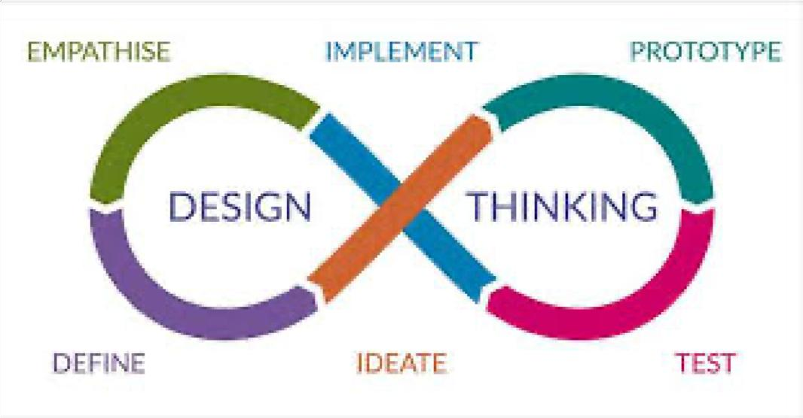

Background Context

In the rapidly evolving healthcare sector, efficient patient management and timely access to medical services are critical for ensuring quality care. However, many hospitals and clinics still rely on traditional queue systems and manual appointment handling, which often lead to long waiting times, overcrowding, and poor patient experience. A significant number of healthcare providers face challenges in managing patient flow effectively, especially during peak hours, resulting in delays and reduced operational efficiency.
With the advancement of digital technologies and AI-powered systems, healthcare management is undergoing a transformation. Smart scheduling systems, real-time tracking, and data-driven insights are helping hospitals improve patient care and streamline operations. According to industry trends, healthcare institutions are increasingly adopting automated systems to enhance efficiency and reduce manual workload.
Despite these advancements, many small and mid-sized clinics still face several challenges, including:
    - Inefficient manual queue management
    - Lack of real-time visibility of patient status
    - Long waiting times and patient dissatisfaction
•Poor coordination between patients and doctors
    - Limited use of data for decision-making
The MEDIQ system addresses these challenges by providing an AI-powered, real-time healthcare queue management and appointment booking platform. It allows

patients to book appointments online, track their position in the queue, and receive live updates about their turn. At the same time, doctors are equipped with a dashboard to manage patient flow, monitor performance, and make informed decisions.
By leveraging technologies like real-time databases (Supabase), interactive dashboards, and intelligent notifications, the system enables:
    - Real-time queue tracking and updates
    - Efficient appointment scheduling
    - Reduced waiting time for patients
    - Improved coordination between patients and doctors
    - Data-driven insights through analytics
The development of MEDIQ reflects a broader shift toward digital healthcare solutions that focus on improving accessibility, efficiency, and patient satisfaction. Such systems are becoming essential in modern healthcare environments, helping institutions deliver better services while optimizing their internal operations.

Chapter 3

Methodology

  - Design Thinking framework
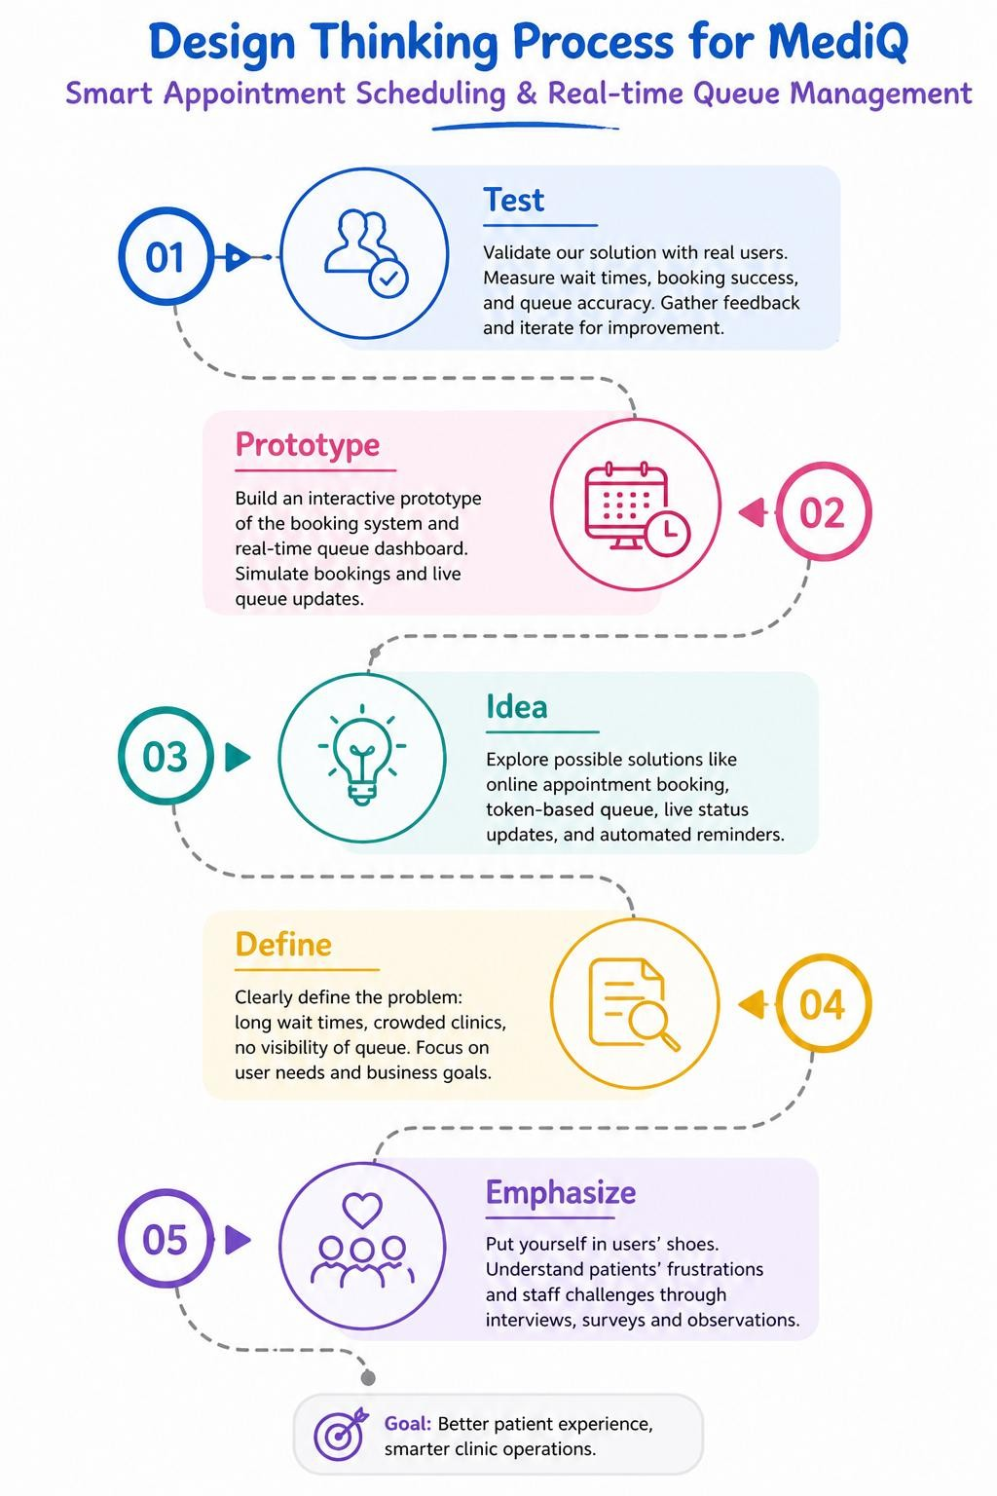

Research methods
The development of the MEDIQ system followed a mixed-methods research approach combining both qualitative and technical research methods. The goal was to understand healthcare challenges, evaluate existing solutions, and design an efficient queue management system.

User-Centered Research
- Empathy Interviews: Informal discussions were conducted with patients and healthcare staff to understand issues like waiting time, appointment delays, and communication gaps.

- Pain Point Mapping: Identified major problems such as overcrowding, lack of real-time updates, and inefficient queue handling systems.

- Observation Studies: Observed traditional hospital workflows to analyze delays, manual errors, and inefficiencies in patient management.

Secondary Research
- Literature Review: Studied research papers and articles on healthcare management systems, queue optimization, and AI-based scheduling.
- Benchmarking: Analyzed existing platforms like hospital management systems and online booking applications to understand current technologies and limitations.

Technical Feasibility Analysis

- Tool Evaluation: Evaluated technologies such as Supabase (real-time database), Tailwind CSS (UI design), and JavaScript frameworks for building an interactive system.

- Prototype Testing: Developed and tested initial versions of the system to ensure real-time data updates, queue accuracy, and smooth user interaction.

Human-Centered Design Approach

- Iterative Prototyping: Multiple versions of the system were created and improved based on feedback from users.

- Usability Testing: Tested features like appointment booking, queue tracking, and doctor dashboard to ensure ease of use and reliability.

- Continuous Refinement: Regular improvements were made to enhance UI design, notification system, and overall performance.

3.3. Innovation approach
The MEDIQ system introduces an innovative, AI-driven solution that transforms traditional hospital queue management and appointment booking into a smart, real-time digital experience.
The platform enables patients to book appointments, track their live queue position, and receive instant updates about their turn—eliminating the need for manual queue systems and reducing waiting time significantly. At the same time, doctors can efficiently manage patient flow through a dedicated dashboard with real-time data and analytics.
Built using modern technologies such as Supabase (real-time database), JavaScript, and interactive web interfaces, the system ensures seamless synchronization between patients and doctors. Features like live queue visualization, estimated waiting time, and automated notifications provide a transparent and efficient healthcare experience.
Designed with a user-friendly approach, MEDIQ offers an intuitive web interface that is easy to use for both patients and healthcare providers, even without technical expertise. Its modular architecture allows the system to scale across multiple hospitals, clinics, and healthcare environments.
Most importantly, MEDIQ reduces manual workload, improves operational efficiency, and enhances patient satisfaction by minimizing delays and improving communication. It bridges the gap between traditional healthcare systems and modern digital solutions, promoting a smarter, faster, and more data-driven healthcare ecosystem.

Chapter – 4

Empathize
Empathize phase focuses on understanding the needs and problems of users. In the MEDIQ system, this involved studying the challenges faced by patients and healthcare staff.
Patients often face long waiting times, lack of clarity about their turn, and difficulty in booking appointments. Doctors and staff struggle with managing queues manually and handling large numbers of patients.
By identifying these issues, key problems such as poor queue management, lack of real-time updates, and inefficient communication were understood. This helped in designing a user-friendly and effective healthcare solution.

Stakeholder Analysis

S.  No | Register No | Team Members | Contribution & Awareness in Project Development
1 | 24KD1A0590 | E.Prathyusha | Oversaw overall project development, coordinated team activities, and contributed to system design and implementation as a technical expert.
2 | 24KD1A05C8 | G. Meghana sree | Critically evaluated project design  and helped in Large Language Model Integration.
3 | 24KD1A05C0 | G. Poojitha | Developed the Synthetic database for unit and overall testing.
4 | 24KD1A0593 | G.Sowjanya | Developed the System interface

5 | 24KD1A0575 | D. Tejaswi | Provided project feedback and  contributed in developing Synthetic DataBase.
6 | 24KD1A05Y6 | S.Anitha | Managed the project, planned meetings, and developed SQL  queries.

User research findings

KeyWord-1 | KeyWord-2 | KeyWord-3 | KeyWord-4 | KeyWord-5
Empathy and  General Care Keywords | Domain Keyword | Technical Keyword | Prototype Keyword | Output Keyword
Team Member 1:  Interest | Industry | Program solving Web  development | software | Project
Team Member 2 :  Interest | Industry Society | Problem solver Web  development | Software | Project
Team Member 3 :  Interest | Society | Programming  Backend integration | Software | Project
Team Member 4 :  Curiosity | Society industry | Programming Problem  solver | Software | Project

Team Member 5 :  Interest | Industry | Problem  solver AI | Software | Project
Team Lead:  Curiosity | Industry | Program solving Web  development | Software | Project

Each member of the MEDIQ team brings a unique combination of empathy and technical expertise driven by values such as curiosity, care for patients, and a desire to improve healthcare systems. These motivations reflect a strong understanding of real-world challenges faced by patients and doctors, aligning with the project’s goal of creating a user-friendly and efficient healthcare solution.

The team shares a common focus on healthcare improvement and societal benefit, aiming to reduce waiting times and enhance patient experience through digital innovation. Technically, the team is well-equipped with skills in web development, real-time database integration, UI/UX design, and system development, ensuring a balanced approach between functionality and user experience.

The team’s commitment to developing a complete solution—from idea generation to implementation—demonstrates a strong dedication to delivering a practical and impactful system. This combination of empathy and technical capability has played a key role in building MEDIQ as an effective and scalable healthcare management platform.

Personas
User Persona: Dr. Srinivas
Age: 40
Occupation: doctor
Location: Vizianagaram, Andhra Pradesh
Education: MBBS

Language: Fluent in Telugu ,English and Hindi
Tech Access: Desktop computer with internet
Technical Skill: Basic computer knowledge; no SQL or programming experience Data Needs: Requires real-time access to patient queue status, crowd levels, and consultation flow to manage patients efficiently

Pain Points:
- Depends on manual systems to manage patient queues
- Finds existing hospital dashboards complex and difficult to use
- Faces difficulty in tracking real-time patient flow
- Concerned about delays and inefficient patient handling

Empathy Maps
An Empathy Map in Design Thinking is a collaborative visualization tool used to gain deeper insight into a user's thoughts, feelings, behaviors, and needs. It helps teams empathize with users by putting themselves in their shoes and understanding their experience more holistically.

SAYS

        - "I don’t know SUPABASE."
        - "I just want quick access to stock or sales data."

THINKS
        - "I wish I didn’t need help every time I need a report."
        - "There should be an easier way to get data."

FEELS
        - Frustrated with complex technical tools
        - Anxious about delays in decision-making

DOES
        - Depends on IT team for reports
        - Avoids using complex dashboards

PAINS
        - Lack of SQL knowledge
        - Dependency on others
        - Slow data access

GAINS
        - Easy and quick data access
        - More control over decision-making

4.4 Pain Points and Needs

Pain Points:
- Manual queue management is time-consuming
- No real-time visibility of patient status
- Difficulty in handling peak patient load
- Lack of proper coordination between patients and doctors
- Risk of delays due to inefficient system

Needs:
- Real-time access to patient queue using Supabase
- Easy appointment booking system
- Live updates and notifications for patients
- Simple and user-friendly interface
- Efficient system to manage patient flow

Outcomes:
- Reduced patient waiting time
- Improved hospital efficiency
- Better coordination between patients and doctors
- Real-time data synchronization using Supabase
- Enhanced patient experience and satisfaction

Chapter – 5

Define
The Define phase is the second stage of the Design Thinking process. It involves synthesizing insights gathered during the Empathize phase to clearly articulate the core problem or challenge that the users are facing.

Problem statement
As healthcare systems become more patient-centric, efficient management of appointments and queues is essential. However, many hospitals and clinics still rely on manual processes, leading to long waiting times, lack of transparency, and poor coordination between patients and doctors.
Patients often struggle to know their queue position or waiting time, while doctors face difficulties in managing patient flow effectively. The absence of real-time updates and digital systems creates delays and reduces overall efficiency.
This gap highlights the need for a smart, real-time healthcare solution that allows patients to book appointments easily, track their queue status, and receive timely updates, while enabling doctors to manage patient flow efficiently.

Point of view (POV) synthesis
Patients and healthcare providers who face challenges in managing appointments and queues need a simple, real-time, and user-friendly system to track patient flow and reduce waiting time, because traditional hospital systems are manual, inefficient, and lack transparency.
This POV helps guide the development of the MEDIQ system, which empowers patients with real-time information, reduces workload for healthcare staff, and improves overall hospital efficiency.

Opportunity areas
The MEDIQ system presents several opportunities to improve healthcare operations: Developing a system that estimates patient waiting time based on doctor specialization and queue length

    - real-time visibility of patient queues for better planning and management
    - Creating a simple and user-friendly interface for non-technical hospital staff
    - Reducing dependency on manual tracking and improving operational efficiency
    - Expanding the system to support multiple departments and hospital branches
    - Providing Integrating with digital dashboards or hospital management systems for better workflow
    - Adding multi-language support for accessibility
    - Enhancing usability with notifications, alerts, and queue updates

Chapter – 6

Ideate
The Ideate phase in Design Thinking is a crucial stage where creative solutions are generated to address real-world healthcare challenges. For a project like MEDIQ, which focuses on real-time appointment booking and queue management, this phase was essential in designing a system that improves patient experience and hospital efficiency.

During this phase, the team focused on:

- Generating Diverse Ideas: Brainstormed features such as real-time queue tracking, estimated waiting time, instant booking system, live status updates, and smart notifications (alerts, sound, and voice prompts) to reduce patient uncertainty.

- Challenging Assumptions: Questioned traditional hospital practices like manual queue handling and long waiting times, and explored how a digital system can provide transparency, automation, and better time management.

- Collaborative Brainstorming: Integrated ideas from UI design (clean dashboard), backend (Supabase real-time database), and system logic (queue number, priority handling) to ensure the system is practical, scalable, and user-friendly.

Brainstorming Sessions
Brainstorming in Design Thinking is a collaborative process used to generate creative
solutions for real-world problems. For the MEDIQ system, sessions focused on improving patient experience and hospital workflow efficiency.

The team explored solutions to challenges like long waiting times, unclear queue status, and manual appointment handling. Open discussion and idea sharing helped identify practical and user-friendly features.

Key ideas included real-time queue tracking, easy appointment booking, wait-time estimation, instant notifications, and role-based dashboards for patients and doctors. These sessions helped finalize features that are both useful and feasible to implement.
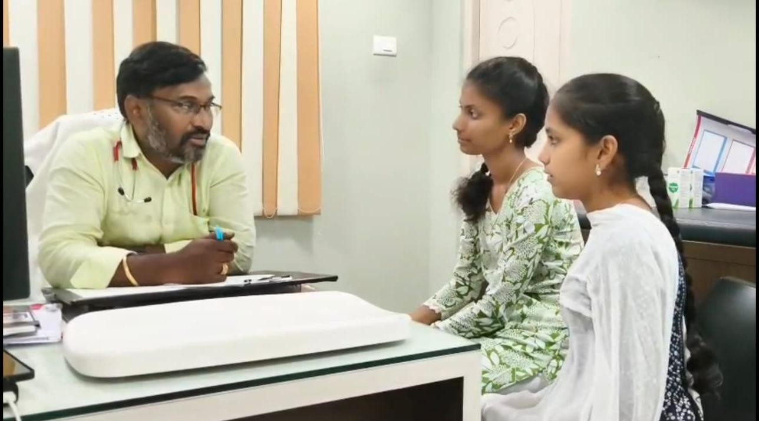

Ideation techniques
Ideate is the third phase of the Design Thinking process, where the focus shifts from understanding the problem to generating innovative solutions. In the MEDIQ project, this phase was used to design a system that simplifies appointment handling and improves real-time patient management.

In Design Thinking:
- Purpose: To generate diverse and practical ideas that improve patient flow, reduce waiting time, and enhance healthcare service efficiency.
- Approach: Encourages creative thinking, team collaboration, and exploration of multiple solutions such as queue visualization, live updates, and smart alerts.
- Tools Used: Brainstorming, simple workflow sketching, feature mapping (booking, queue, analytics), and “How Might We” questions like “How might we reduce patient waiting time?”
- Outcome: A set of user-centered features including real-time queue system, appointment booking interface, doctor dashboard, and AI-based insights, which were later implemented and tested

Idea evaluation criteria

Criteria | Description | Evaluation Questions
1. User Accessibility | Ensures that both patients and  doctors can easily use the system without technical knowledge. | Can patients book appointments  easily? Is the interface simple for first-time users?
2. Language Flexibility | Provides a clean and intuitive UI for smooth navigation across booking, queue tracking, and  dashboards. | Is the system easy to navigate? Can users quickly understand features like queue status and booking?
3. Equity & Inclusion | Makes healthcare services more accessible to users from different  backgrounds and skill levels. | Does it reduce confusion for patients? Can non-technical users  interact with the system effectively?
4. Data Accuracy & Reliability | Ensures correct display of queue  position, appointment details, and real-time updates | Are queue numbers and statuses  accurate? Is data consistent across patient and doctor views?
5. Technological Feasibility | Built using existing technologies like real-time databases and web frameworks. | Can the system handle real-time updates efficiently? Does it integrate well with backend services  like Supabase?
6. Trust & Safety | Maintains user data privacy and  ensures role-based access control. | Is patient data secure? Are  unauthorized users restricted from accessing certain features?
7. Impact & Reach | Improves hospital efficiency and patient experience through  digital transformation. | Does it reduce waiting time? Can it be used in clinics, hospitals, and  healthcare centers?
8. Cost-Effectiveness | Designed to be affordable and  scalable using cloud-based solutions. | Can small clinics adopt it easily?  Does it require minimal infrastructure?
9. Integration Potential | Can be extended to integrate with other healthcare systems and tools. | Can it connect with hospital systems or mobile apps? Can it scale for larger healthcare networks?

Shortlisted concepts
The team presented the shortlisted ideas in detail, focusing on practical solutions to improve patient experience and hospital workflow efficiency.

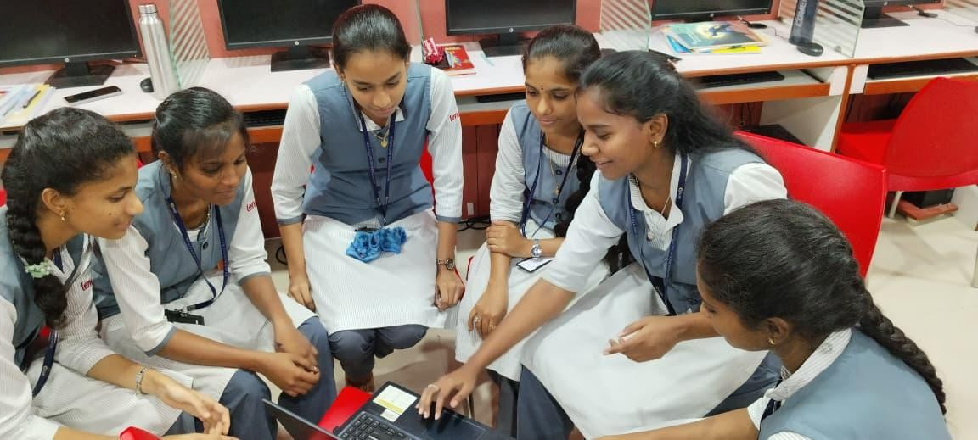

Smart Appointment Booking System
Enables patients to easily search for doctors, select time slots, and confirm appointments through a simple interface.

Real-Time Queue Management
Provides live tracking of patient queue position, estimated waiting time, and consultation status.

Instant Notifications & Alerts
Includes sound alerts, pop-ups, and voice notifications (e.g., “You are next”) to keep patients informed.

Doctor Dashboard with Analytics
Allows doctors to manage patient queues, monitor consultations, and view performance insights through visual charts.

Role-Based Web Interface
Separate dashboards for patients and doctors with secure access control and personalized features.

Scalable Cloud-Based System
Built using real-time backend (Supabase), enabling live updates and scalability for multiple users and clinics.

Chapter 7

Prototype

In Design Thinking, the Prototype phase involves creating a working model of the solution. For the MEDIQ system, a web-based prototype was developed with features like appointment booking, real-time queue tracking, and doctor dashboards. This helped test user interaction, system functionality, and identify improvements before final implementation.

7.1 Prototype Development Process

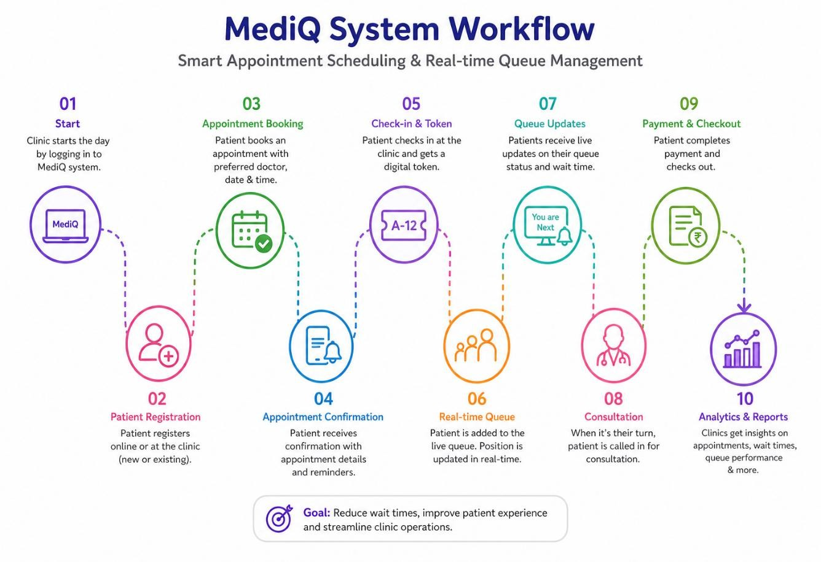

Code for RenderQueue for Doctors :
,
function renderQueue() {

let waiting = queue.filter(p => p.status === "waiting");
let inProgress = queue.filter(p => p.status === "in_consultation");
let done = queue.filter(p => p.status === "completed");
document.getElementById("totalPatients").innerText = queue.length;
document.getElementById("appointments").innerText = queue.length;
document.getElementById("dashboardWaitingCount").innerText = waiting.length;
document.getElementById("queueWaitingCount").innerText = waiting.length;
document.getElementById("currentCount").innerText = inProgress.length;
document.getElementById("doneCount").innerText = done.length;

let current = inProgress[0];

// CURRENT PATIENT UI
if (current)
{
document.getElementById("currentName").innerText = current.name;
document.getElementById("currentIssue").innerText = current.issue || "General";
document.getElementById("currentAvatar").innerText =
current.name.charAt(0).toUpperCase();
}
else
{
document.getElementById("currentName").innerText = "No Active Patient";
document.getElementById("currentIssue").innerText = "---";
document.getElementById("currentAvatar").innerText = "-";
}

// QUEUE AVATARS (NEW STYLE)
const queueBox = document.getElementById("queueAvatars");

if (queueBox) {
queueBox.innerHTML = queue.map((p, i) => `
<div class="w-10 h-10 rounded-full flex items-center justify-center
${p.status === 'in_consultation'
? 'bg-green-500 heartbeat'
: p.status === 'waiting'
? 'bg-blue-500/40'
: 'bg-gray-500'}">
👤
</div>
`).join('');
} }

Code to activateEmergency

async function activateEmergency() {

// 🔴 Get first waiting patient (top of queue)
const { data, error } = await supabaseClient
.from('bookings')
.select('*')
.eq('doctor_id', Number(doctorId))
.eq('status', 'waiting')
.order('queue_number', { ascending: true })
.limit(1);

if (error || !data || data.length === 0) {
alert("No waiting patients");
return;
}

const patient = data[0];

// 🔥 Mark as emergency
const { error: updateError } = await supabaseClient
.from('bookings')
.update({
is_emergency: true,
priority: 3
})
.eq('id', patient.id);

if (updateError) {
alert("Error activating emergency");
return;
}

alert("🚨 Emergency activated for next patient");

loadQueue(); }

Code for LoadQueue :

async function loadQueue() {
const { data, error } = await supabaseClient
.from('bookings')
.select('*')
.eq('doctor_id', doctorId) // ✅ ONLY THIS DOCTOR
.order('priority', { ascending: false })
.order('queue_number', { ascending: true });
if (error) {
console.error(error);
return;
}

queue = data.map(b => ({
name: b.patient_name || "Patient",
issue: "General",
status: (b.status || "").trim().toLowerCase(), // ✅ FIX
id: b.id
}));

console.log("Doctor ID:", doctorId);
console.log("Bookings:", data);
updateAICharts(data);
updateAISuggestions(data);
updatePerformanceChart(data);
// Ensure one patient is active
if (!queue.some(p => p.status === "in_consultation")){
const firstWaiting = queue.find(p => p.status === "waiting");

if (firstWaiting) {
await startConsultation(firstWaiting.id);
return loadQueue();
}
}
renderQueue();
console.log("Statuses:", queue.map(q => q.status));

}

Code for RenderDoctors for Patients:

function renderDoctors() {
const grid = document.getElementById('doctor-grid');
grid.innerHTML = doctors.map(doc => `
<div class="glass p-5 rounded-2xl border border-gray-100 shadow-sm hover:shadow-md transition group">
<div class="flex items-start justify-between mb-4">
<div class="w-12 h-12 bg-blue-100 rounded-lg flex items-center justify-center text-blue-600 font-bold text-[10px] text-center p-1 leading-tight">
${doc.img ? doc.img.substring(0, 2).toUpperCase() : 'DR'}
</div>
<span class="text-xs font-bold px-2 py-1 rounded-full ${doc.crowd === 'Low' ? 'bg-green-100 text-green-600' : 'bg-orange-100 text-orange-600'}">
${doc.crowd} Crowd
</span>
</div>
<h3 class="font-bold text-white group-hover:text-blue-600 transition text-sm leading-tight">
${highlightText(doc.name, document.getElementById('searchInput').value)}
</h3>

<p class="text-xs text-gray-400 mb-3">
${highlightText(doc.spec, document.getElementById('searchInput').value)}
</p>
<div class="flex items-center gap-4 mb-5 text-sm">
<div class="flex items-center gap-1 text-yellow-500 font-bold">
<i data-lucide="star" class="w-4 h-4 fill-current"></i> ${doc.rating}
</div>
<div class="text-gray-400">|</div>
<div class="font-semibold">₹${doc.fee}</div>
</div>
<button onclick="openBooking(${doc.id})" class="w-full py-2 bg-blue-600 text-white hover:bg-blue-700 font-semibold rounded-lg hover:bg-blue-600 hover:text-white transition">
Book Now
</button>
</div>
`).join('');
lucide.createIcons();
}

Description of Prototype
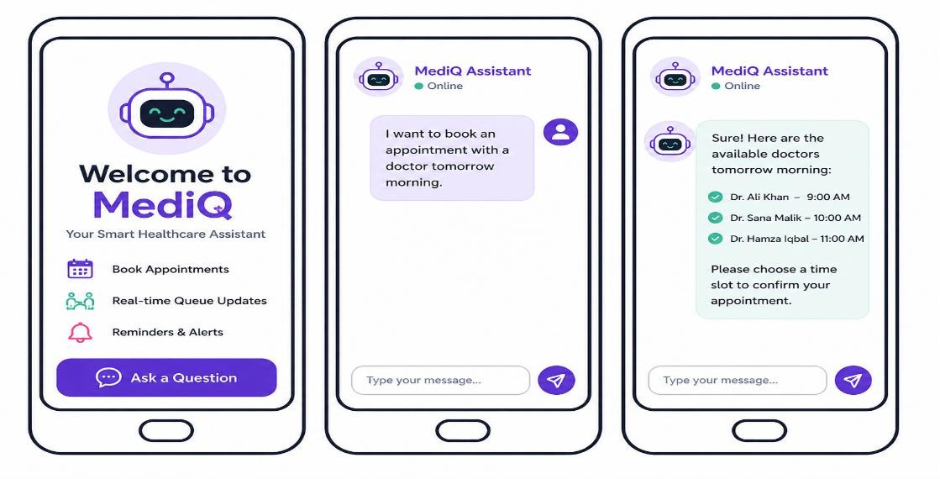

  - Tools and Materials used

Hardware Requirements:

    - Cloud Infrastructure: Supabase cloud platform for backend and real-time database
    - Client Devices: Laptops or mobile devices with internet access and modern browsers
    - Developer Systems: Local systems for coding (HTML, JavaScript) and testing

Software Requirements:

Frontend:

    - HTML5, CSS3, JavaScript – Core technologies for building the UI
    - Tailwind CSS – For responsive and modern UI design
    - Lucide Icons – For UI icons and visuals

Backend & Database:

    - Supabase (PostgreSQL) – Handles database, authentication, and real-time updates

Real-Time Features:

    - Supabase Realtime Channels – Enables live queue updates and notifications

Visualization & Analytics:
    - Chart.js – Used for displaying analytics in doctor dashboard

Audio & Alerts:
- Web Speech API – Voice alerts for patient notifications
- HTML Audio API – Notification sounds

Admin & Monitoring:
- Browser Local Storage – Stores user session (role, username, doctor ID)
- Console Logs – Used for debugging and monitoring

Chapter 8

Test
  - User Testing Methodology

- Evaluate the usability of the system interface for both patients and doctors, including ease of navigation, appointment booking, and queue tracking features.
- Test the accuracy and reliability of real-time data updates such as queue position, appointment status, and doctor availability.
- Identify user comprehension issues related to system messages, notifications (e.g., “You are next”), and dashboard insights.
- Assess system response time for key actions like booking an appointment, updating queue status, and loading analytics.
- Verify data correctness by comparing system outputs (appointments, queue numbers, status updates) with expected results stored in the database.
- Measure user satisfaction and trust in features such as smart notifications, real-time queue visualization, and AI-based insights.
- Check the effectiveness of error handling for scenarios like invalid inputs, missing selections (e.g., no time slot chosen), and unauthorized access.
- Conduct testing with different user roles (patient and doctor) to ensure role-based access control and functionality work correctly.

Target Users and Stakeholders of this System :
- Patients
- Doctors
- Hospital / Clinic Administrators
- Receptionists / Support Staff
- Developers / System Administrators
- Healthcare Data Analysts / Business Intelligence Team

Visual Walkthrough of MEDIQ- Doctor Interface
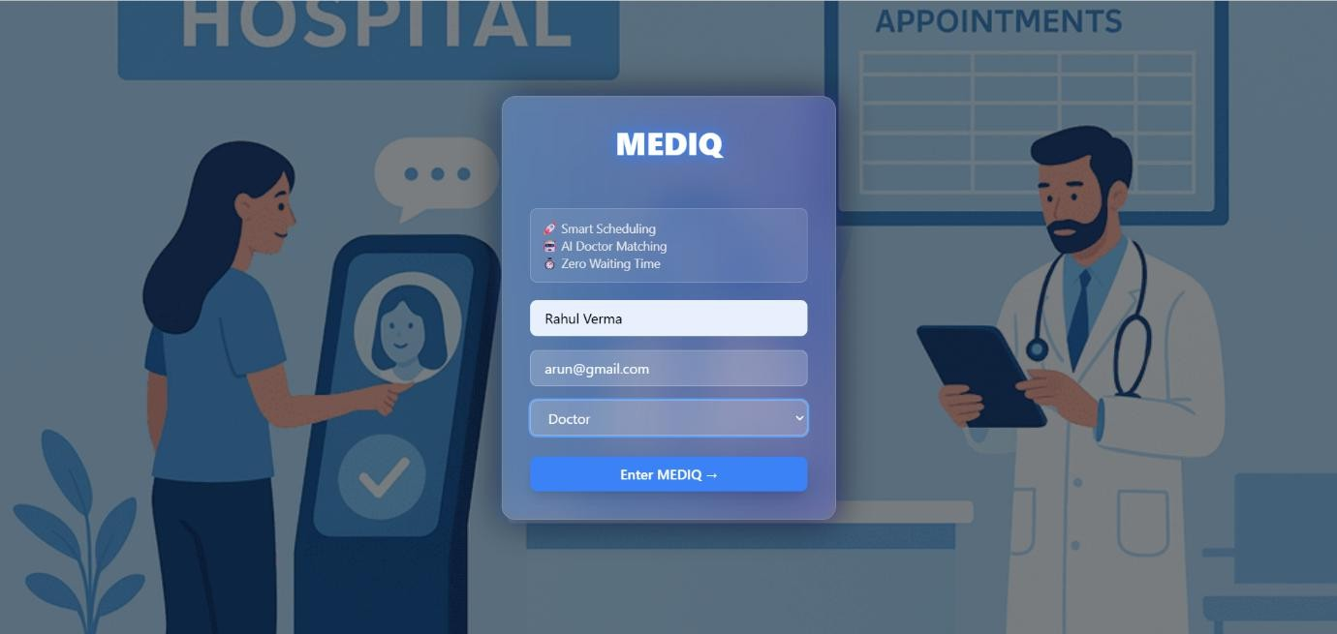

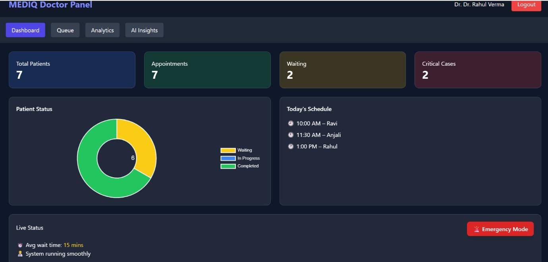

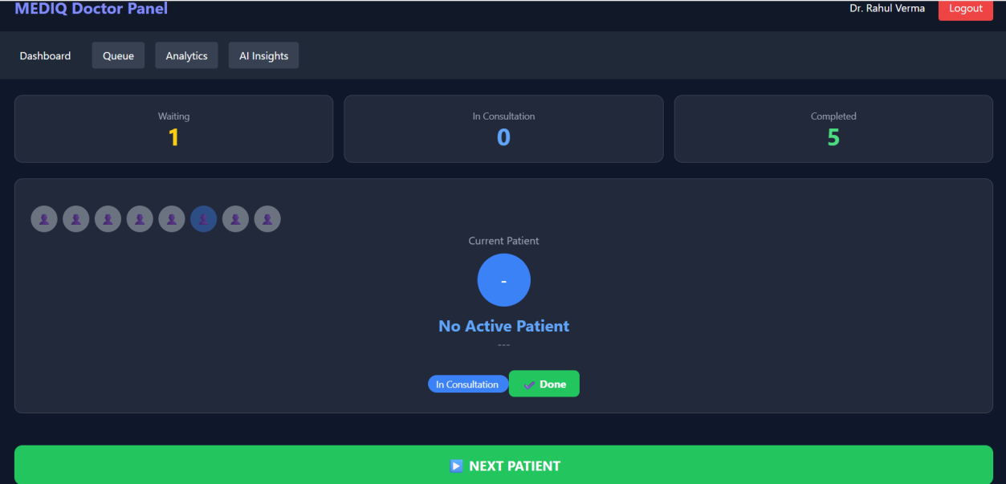

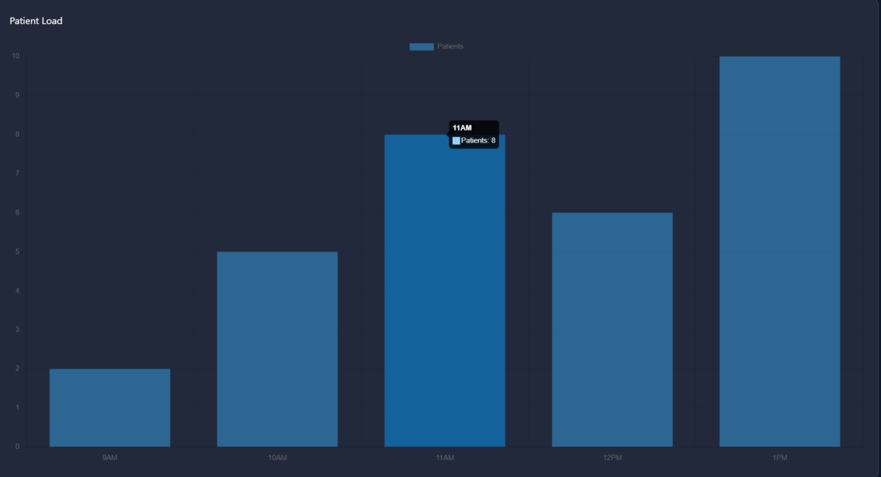
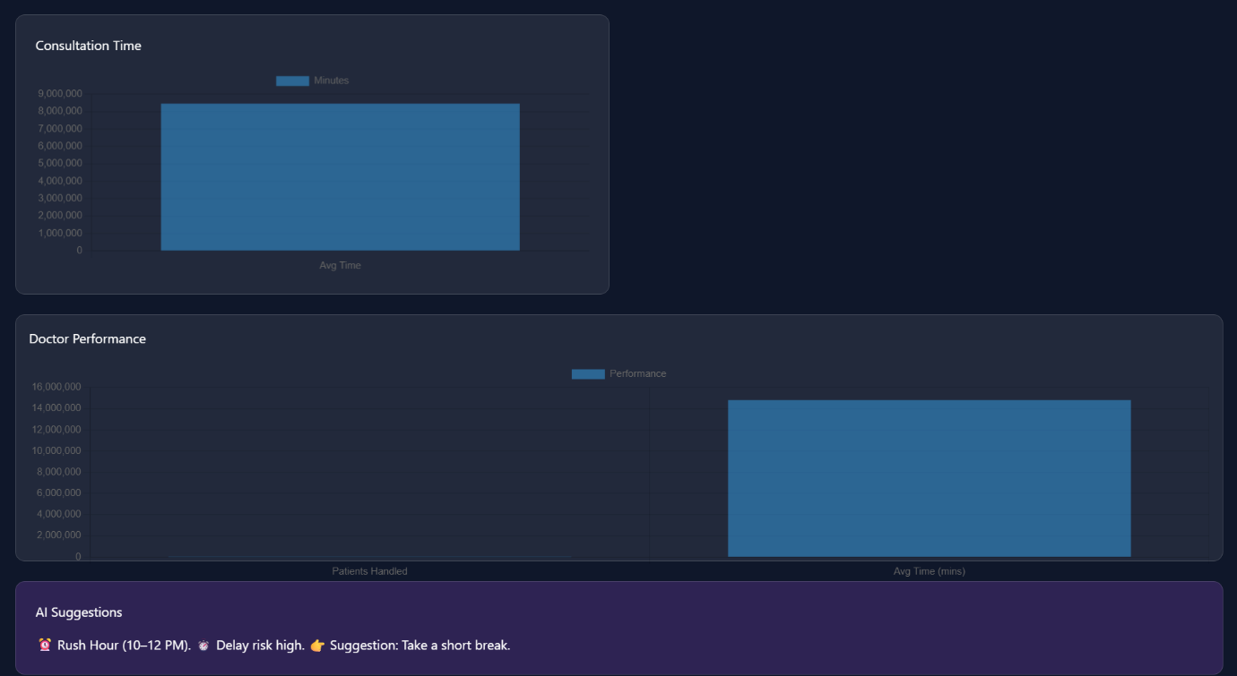

Visual Walkthrough of MEDIQ- Patient Interface
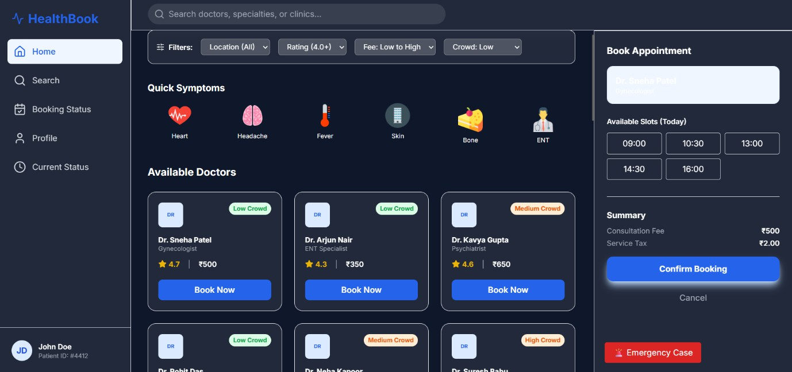
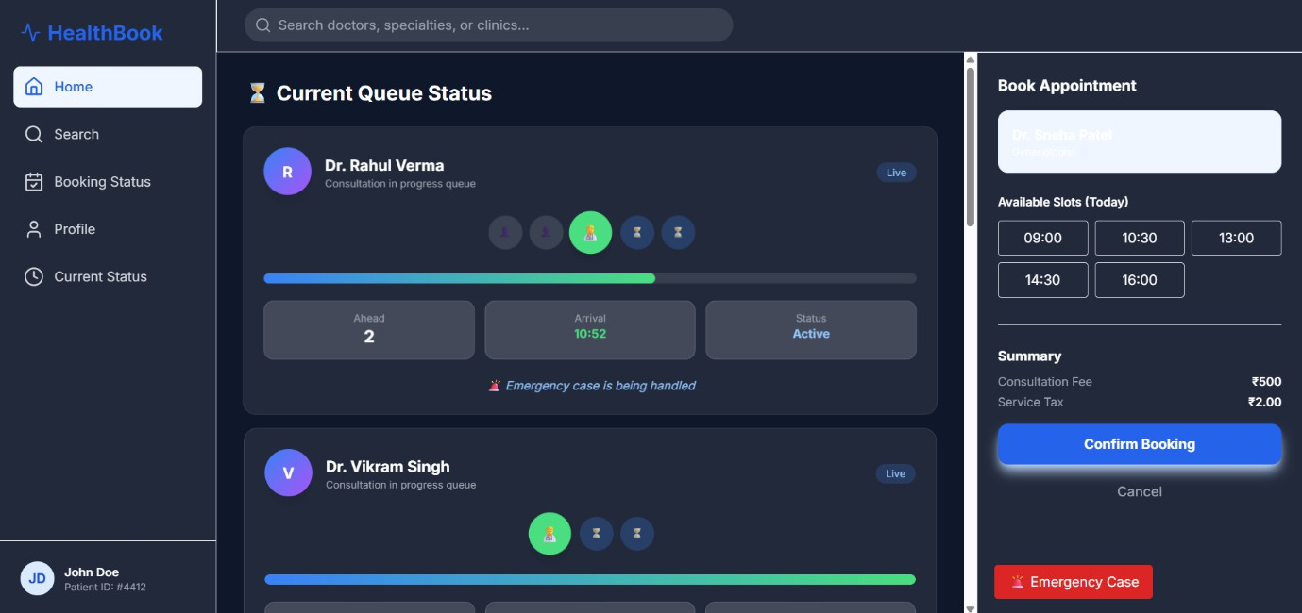

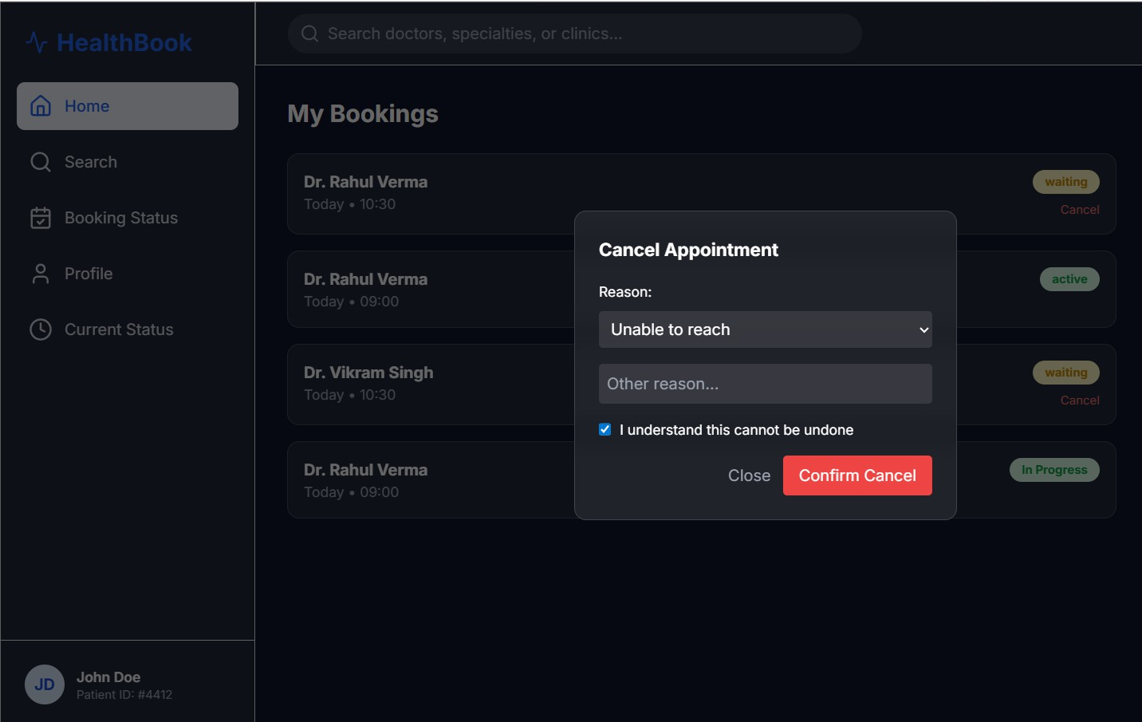

Feedback and Observations

Accuracy Check
    - Validated system outputs such as queue position, appointment status, and analytics data for correctness.
    - Cross-verified results with database values to ensure logical consistency.

User Interaction Testing
    - Tested user actions like booking appointments, selecting doctors, and tracking queue status.
    - Structured inputs (e.g., selecting slots properly) produced more reliable outcomes than incomplete actions.

User Interface Observations
    - Users appreciated the clean, modern interface and intuitive navigation.
    - First-time users required minimal guidance, indicating good usability.

Error Handling
    - System handled invalid inputs (e.g., no time slot selected, wrong access role) effectively.
    - Error messages were clear and user-friendly, improving user confidence.

Performance
    - Most operations (booking, loading data, queue updates) were fast and responsive.
    - Real-time updates ensured accurate and consistent information across the system.

Lessons Learned

Ensuring Data Accuracy:
Users depend on the system for correct appointment details, queue positions, and status updates. Any inconsistency can affect patient experience and doctor workflow. Continuous testing improved reliability.

Lesson Learned:
Always validate system outputs with database data to ensure accuracy and maintain user trust.

Data Transparency and Security:
Users showed concern about how personal and medical-related data is handled within the system. Providing clarity on data storage and access improved confidence.

Lesson Learned:
Ensure secure data handling with proper access control and clearly communicate data usage policies to users.

User-Centric Design:
Both patients and doctors preferred a simple, intuitive interface for booking, queue tracking, and dashboard usage. Complex interactions reduced usability.

Lesson Learned:
Design clean and user-friendly interfaces with clear actions and guidance to make the system accessible for all user types.

Chapter 9

Innovation Goals

MEDIQ – AI-Powered Smart Healthcare Queue & Appointment System

Smart Appointment Booking System

    - Function: Enables patients to search, filter, and book doctor appointments through an intuitive interface.
    - Design: Includes filters like specialization, rating, location, and crowd level.
    - Impact: Simplifies the booking process and reduces manual scheduling efforts.

Real-Time Queue Management

    - Function: Tracks live patient queue positions and consultation progress.
    - Design: Provides visual indicators, estimated wait time, and “You are next” alerts.
    - Impact: Reduces waiting uncertainty and improves patient experience in
clinics/hospitals.

AI-Driven Insights for Doctors

    - Function: Analyzes patient load, consultation time, and system performance.
    - Design: Integrated dashboards with charts and smart suggestions (e.g., rush hour alerts, delay risks).
    - Impact: Helps doctors optimize workflow and improve efficiency in handling patients.

Automated Notifications and Alerts

    - Function: Sends real-time alerts for booking confirmation, queue updates, and consultation status.

    - Design: Includes sound alerts, pop-ups, and voice notifications.
    - Impact: Keeps users informed and reduces missed appointments.

Role-Based Secure System

    - Function: Provides separate dashboards and access control for patients and doctors.
    - Design: Implements role verification and restricted access using local storage and backend validation.
    - Impact: Ensures data privacy, security, and proper system usage.

Scalable and Real-Time Architecture

    - Function: Uses cloud-based backend (Supabase) for real-time data synchronization.
    - Design: Supports multiple users simultaneously with live updates across dashboards.
    - Impact: Enables scalability for hospitals, clinics, and future healthcare expansions

Business model implications

Freemium Service Model
MEDIQ can offer basic features such as patient queue display and waiting time estimation for free to small clinics or hospitals. Advanced features like multi-department management, analytics dashboards, and notifications can be provided through paid subscription plans.

B2B (Business-to-Business) Licensing
Hospitals, clinics, and healthcare chains can license the MEDIQ system for internal use. Custom integrations with existing hospital management systems and dedicated support services can be offered to improve operational efficiency.

B2G (Business-to-Government) Opportunities
MEDIQ can be implemented in government hospitals and public healthcare centers to improve patient flow management and reduce waiting times.

Collaboration with digital healthcare initiatives can enhance large-scale adoption.

White-Label Solutions
The system can be customized and integrated into third-party hospital management software or healthcare platforms as a white-label solution, enabling other providers to use MEDIQ under their own branding.

Strategic Partnerships
Partnerships with healthcare technology providers, hospital software vendors, and cloud service providers can help expand the reach of MEDIQ and ensure smooth integration with existing systems.

Implementation roadmap

Phase | Goal | Key Activities
Phase I – Ideation & Planning | Define project scope and features | Identify core functionalities such as patient queue management and waiting time estimation. Define target users (doctors, hospital staff)  and system requirements..
Phase II – Research & Feasibility | Validate technical and business needs | Study existing hospital queue systems, identify problems like long waiting times and manual tracking, and analyze feasibility of implementation.

Phase III – Design & Prototyping | Develop initial UI and AI logic | Design user interface for displaying patient queues and waiting time. Create initial prototype for basic  functionality and workflow
Phase IV – Development | Build core AI system | Develop frontend and backend. Integrate Supabase database for storing patient and queue data. Implement logic for waiting time estimation based on  specialization
Phase V – Testing & Feedback | Validate system performance | Test system with sample data and users. Collect feedback on usability, accuracy, and performance. Fix errors and improve interface.
Phase VI – Business Model & Integration | Prepare for scaling and monetization | Integrate all modules including database, UI, and logic. Ensure smooth functioning and real-time updates.
Phase VII – Deployment & Expansion | Launch and prepare for scale | Deploy the application and prepare for future enhancements like multi-department support and notifications.

Chapter 10

Conclusion
MEDIQ redefines how hospitals manage patient flow by offering a simple and efficient system for queue management and waiting time estimation based on doctor specialization. By eliminating confusion and reducing dependency on manual processes, the platform enables hospital staff to manage patients more effectively and make quicker decisions.

This solution bridges the gap between patient management and real-time information access. What was once a challenge for hospital staff—tracking queues and estimating waiting time—has now become a clear, streamlined, and user-friendly process. The system ensures accuracy, transparency, and improved coordination within healthcare environments.

More than just a system, MEDIQ represents a step toward smarter healthcare management. It promotes better patient experience, reduces waiting time uncertainty, and enhances operational efficiency. Designed to be scalable and adaptable, it can be extended to multiple departments and healthcare facilities.

This is not just the completion of a project—it is the beginning of a more organized and efficient approach to patient management. MEDIQ is not just solving a problem; it is improving the way healthcare services are delivered

References
- Tailwind CSS Official Documentation. Retrieved from https://tailwindcss.com/docs
- Lakshmi C., & Sivakumar Appa Iyer. (2013). Application of Queueing Theory in Healthcare: A Literature Review. Operations Research for Health Care, Elsevier.
- Chart.js Official Documentation. Retrieved from https://www.chartjs.org/docs
- OpenAI. (2023). GPT-4 Technical Report. Retrieved from https://openai.com/research
- Supabase JavaScript Documentation. Retrieved from https://supabase.com/docs/reference/javascript
- World Health Organization. Digital Health Resources. Retrieved from https://www.who.int
- Ayushman Bharat Digital Mission Official Portal. Retrieved from https://abdm.gov.in
- Google Developers. (2024). Gemini API Documentation. Retrieved from https://developers.google.com/gemini
- React Official Documentation. Retrieved from https://react.dev
- TypeScript Official Documentation. Retrieved from https://www.typescriptlang.org/docs
- MDN Web Docs. JavaScript Guide and Web Development Resources. Retrieved from https://developer.mozilla.org
- Vite Official Documentation. Retrieved from https://vitejs.dev/guide
- Firebase Documentation. Retrieved from https://firebase.google.com/docs
- National Health Authority, Government of India. Digital Health Ecosystem Resources. Retrieved from https://nha.gov.in
- World Health Organization. Global Strategy on Digital Health 2020–2025. Retrieved from https://www.who.int
- Mozilla Developer Network. HTML and CSS Reference Guide. Retrieved from https://developer.mozilla.org
- Node.js Official Documentation. Retrieved from https://nodejs.org/docs/latest/api
- ECMAScript Language Specification. ECMA International. Retrieved from https://tc39.es/ecma262/

DEPARTMENT OF COMPUTER SCIENCE AND ENGINEERING VISION

To emerge as a center of excellence in Computer Science and Engineering to create précised intelligent systems to replicate human intelligence at par, enabling globally competent graduates with human values.

MISSION

- Developing well-equipped infrastructure and laboratories with state-of-the-art technologies and research-driven teaching and learning methodologies with a well-designed innovative curriculum.

- Providing hands-on experience that encourages problem-solving, critical thinking, and interdisciplinary applications to foster research activities through institute and industry collaborations.

- Equipping students with technical expertise, ethical values, and leadership qualities to address real-world challenges and develop globally competent professionals.

- Promoting ethical AI practices and sustainable technological advancements for societal well-being to instil human values and social responsibility.

PROGRAM EDUCATIONAL OBJECTIVES (PEOs)

- Graduates will have a solid foundation in Computer Science and Engineering, enabling them to solve real-world problems, contribute to innovation, and pursue successful careers in industry or higher studies.

- Graduates will possess strong programming skills, knowledge of database management, web technologies, and system design, enabling them to develop

efficient and user-friendly applications for practical domains such as healthcare management systems.
- Graduates will be skilled in working within interdisciplinary and multidisciplinary teams, demonstrating professionalism, ethical conduct, and a strong sense of social responsibility, while adapting to evolving technologies and contributing to societal development through effective technical and leadership skills.

PROGRAM OUTCOMES (POs)
- Engineering Knowledge:
Applied fundamentals of computer science and software engineering to develop the MEDIQ system for managing patient queues and estimating waiting time based on specialization...

Problem Analysis:
Identified issues in hospital queue management such as long waiting times, lack of clarity, and dependency on manual processes, and analyzed them to design an effective solution.
.

Design/Development of Solutions:
Designed a user-friendly system that estimates patient waiting time and improves hospital workflow while considering usability and healthcare needs

Conduct Investigations of Complex Problems:
Studied existing hospital management practices and evaluated system performance through testing and user feedback to improve accuracy and efficiency..

Modern Tool Usage:
Utilized modern tools and technologies such as Supabase (database), web technologies, and UI frameworks to build and deploy the system.

The Engineer and Society:
Developed a solution that improves patient experience and supports hospital staff, contributing positively to healthcare services.

- Environment and Sustainability: Promoted a digital system that reduces paperwork and supports efficient resource utilization in hospitals.

Ethics:
Ensured responsible handling of patient data with attention to privacy, security, and ethical standards

Individual and Team Work:
Worked collaboratively as a team, contributing to different modules such as frontend, backend, and system integration

Communication:
Effectively communicated project ideas, system design, and results through reports, presentations, and documentation.

Project Management and Finance:
Managed project planning, task allocation, and development within available resources and time constraints.

Life-Long Learning:
Adapted to new tools and technologies like Supabase and continuously improved skills relevant to real-world problem solving.

PROGRAM SPECIFIC OUTCOMES (PSOs)
- Apply knowledge using modern tools related to Computer Science and Engineering for solving real-world problems.
- Develop applications based on machine learning models and artificial intelligence tools.
- Qualify in national and international competitive examinations for successful higher studies and employment.

COURSE OUTCOMES:

S.NO | DESCRIPTION | PO(1..12) MAPPING | PSO(1..3) MAPPING
CO-1 | Explain the fundamentals of Design Thinking and Innovation. | PO1, 2, 3,  4, 5, 6, 7,  8, 9,10, 11, 12 | PSO1, 2, 3
CO-2 | Apply the design thinking techniques for solving proble various sectors. | PO1, 2, 3,  4, 5, 6, 7,  8, 9,10, 11,  12 | PSO1, 2, 3
CO-3 | Analyze to work in a multidisciplinary environment. | PO1, 2, 3,  4, 5, 6, 7,8, 9,10,  11,  12 | PSO1, 2, 3
CO-4 | Evaluate the value of creativity. | PO1, 2, 3,  4, 5, 6, 7,  8, 9,10, 11,  12 | PSO1, 2, 3

 | Formulate specific problem | PO1, 2, 3, | PSO1, 2, 3
CO-5 | statements of real time issues. | 4, 5, 6, 7,
 |  | 8, 9,10, 11,
 |  | 12
COURSE OVERALL PO/PSO MAPPING: PO1, 2, 3, 4, 5, 6, 7, 8, 9,10, 11, 12 and
PSO1, 2, 3
COURSE OUTCOMES VS POs MAPPING (DETAILED; HIGH:3;MEDIUM:2;LOW:1):

SNO | PO  1 | PO  2 | PO  3 | PO  4 | PO  5 | PO  6 | PO  7 | PO  8 | PO  9 | PO  10 | PO  11 | PO  12 | PSO  1 | PSO  2 | PSO  3
CO-1 | 3 | 3 | 3 | 3 | 2 | 1 | 1 | 2 | 3 | 3 | 1 | 2 | 3 | 2 | 1
CO-2 | 3 | 3 | 3 | 3 | 3 | 1 | 1 | 2 | 3 | 2 | 2 | 2 | 3 | 1 | 2
CO-3 | 3 | 3 | 3 | 3 | 3 | 2 | 2 | 2 | 3 | 2 | 2 | 3 | 2 | 1 | 1
CO-4 | 3 | 3 | 3 | 2 | 3 | 2 | 2 | 2 | 3 | 2 | 2 | 2 | 2 | 1 | 1
CO-5 | 3 | 3 | 3 | 2 | 3 | 2 | 2 | 2 | 3 | 3 | 3 | 3 | 2 | 1 | 1
CO-6 | 3 | 3 | 3 | 3 | 3 | 2 | 2 | 2 | 3 | 2 | 2 | 2 | 2 | 1 | 1

* For Entire Course, PO & PSO Mapping

STUDENTS MAPPING FOR THE PROJECT TITLE

SNO | PO  1 | PO  2 | PO  3 | PO  4 | PO  5 | PO  6 | PO  7 | PO  8 | PO  9 | PO  10 | PO  11 | PO  12 | PSO  1 | PSO  2 | PSO  3

CO-1
CO-2
CO-3
CO-4
CO-5
CO-6

SNO | P  O 1 | P  O 2 | P  O 3 | P  O 4 | P  O 5 | P  O 6 | P  O 7 | P  O 8 | P  O 9 | P  O 10 | P  O 11 | P  O 12 | PS  O 1 | PS  O 2 | PS  O 3
Target
Obtaine
d

Appendices

- Interview Transcripts

- Survey data

- Detailed Personas

- Additional Diagrams or Charts

